Privacy and Security of Data Concerns of IoT Technologies for Visually Impaired People: Methodology

Aitkazy B., Bekbulat A., Baktash A.P., Kurmanbekov A., Turtulov R.
SE-2312, Astana IT University
MiII 3222: Research Methods and Tools
Instructor: Altynbek Seitenov
October 2025

Methodology

Through the qualitative approaches of interviewing professionals in the field but also functional system designs, the weaknesses of the communications and transport protocols etc. involved with the IoT secured devices for the blind will be highlighted. It is intended to show the weaknesses arising from communications and transport protocols inherent in their methodologies of the building of security and privacy, which arise due to the problems generally existing in the IoT world and environment. The importance of the building of security and privacy due to the systems as outlined in previous studies is extremely important in the building of IoT systems for the handicap, as their data being of a delicate nature, requires also, a building of operations which are being of a contextual relevant nature [1].

- Sampling Techniques

Sampling Method:
The sampling process to be employed in this work will be purposive systematic sampling. Those involved with the IoT industry mostly, especially in the fields of communications protocols, assistive technology or cyber well be selected and chosen manually from the communities and forums consulted by these professionals through links in groups etc. and the academic community etc. This sampling process will ensure that the responder basis is in fact one of persons of good working knowledge of the area of IoT security systems with knowledge of the weaknesses existing in the area of the protocols.

Target population:
The target population of responders will be more those involved in the area of the IoT programming and development, that is the producer of embedded systems , or that are working in the fields of cyber security, that are also working with the general communications protocols such as e.g. the MQTT, CoAP Zigbee and BLE etc. The significance of the responders being professionals in their work, is given as the area of work involves an area of technology, and an appreciation of the general nature of these systems and behaviours where there is low power density and restriction of communications in a general area will be necessary. Rosiak et al. [2] point out on a number of levels, that the provision of a secure and stable communications area for the IoT systems in door requires a number of different and interactive factors, such as for example the density of beacon, dynamic environments, communications intrusions resulting from areas of physical matter impeding the communications etc will require extensive knowledge of the area for a proper understanding of the constructions and problems falling therefrom.

Bias mitigation:
To remove any possible bias in the study and to gain a balanced opportunity of inter relationships as between the different opinions, perspectives of the different professionals in their various work will persons be chosen from along a wide range of backgrounds, or otherwise involved in the various types of work etc. i.e. the group to be studied will be made up of various professionals from the system architect to the software engineer, which will give a good balance of opinion coming from the varying scholarly and industrial environments. This will allow then for an overall outlook to be gotten or obtained and one opinion not dominate and cause a prevention or an impediment to the objectivity of the probable conclusions to be prejudged from any outcome of coverage in the research. The result of the study thus will lead to a degree of general credibility which will higher.
Justification for Interviewee Selection and Contribution to Research
- Expertise Diversity for Comprehensive Insights The study includes experts with different backgrounds in IoT systems. This gives a full view of security and privacy problems in assistive devices for visually impaired people. An associate professor who leads in intelligent systems brings deep knowledge of system design and research. Experienced student specialists add practical views from recent projects on IoT protocols. A teacher in computer networks gives insights on communication weaknesses and transport layers. This mix helps cover technical, practical, and teaching sides of the topic.
- Experienced Participants for Reliable Feedback All selected people have worked with IoT protocols like MQTT, CoAP, Zigbee, or BLE for at least one year. This ensures they know the real challenges in low-power devices. Their experience helps find true vulnerabilities and suggest fixes that fit assistive tools. It makes the data strong and useful for the research goals.
- Relevance Through Purposive Sampling Purposive sampling picks people who match the study needs. It focuses on those with direct IoT security knowledge for vulnerable users. This is better than random choice because it gives detailed, expert data. In qualitative work, it helps understand complex issues like privacy-by-design in wearable systems.
- Rationale for Sample Size The plan targets three to five experts. This size balances different views with deep analysis. It lets the study explore each person's input fully. It supports finding common themes on security trade-offs and accessibility.
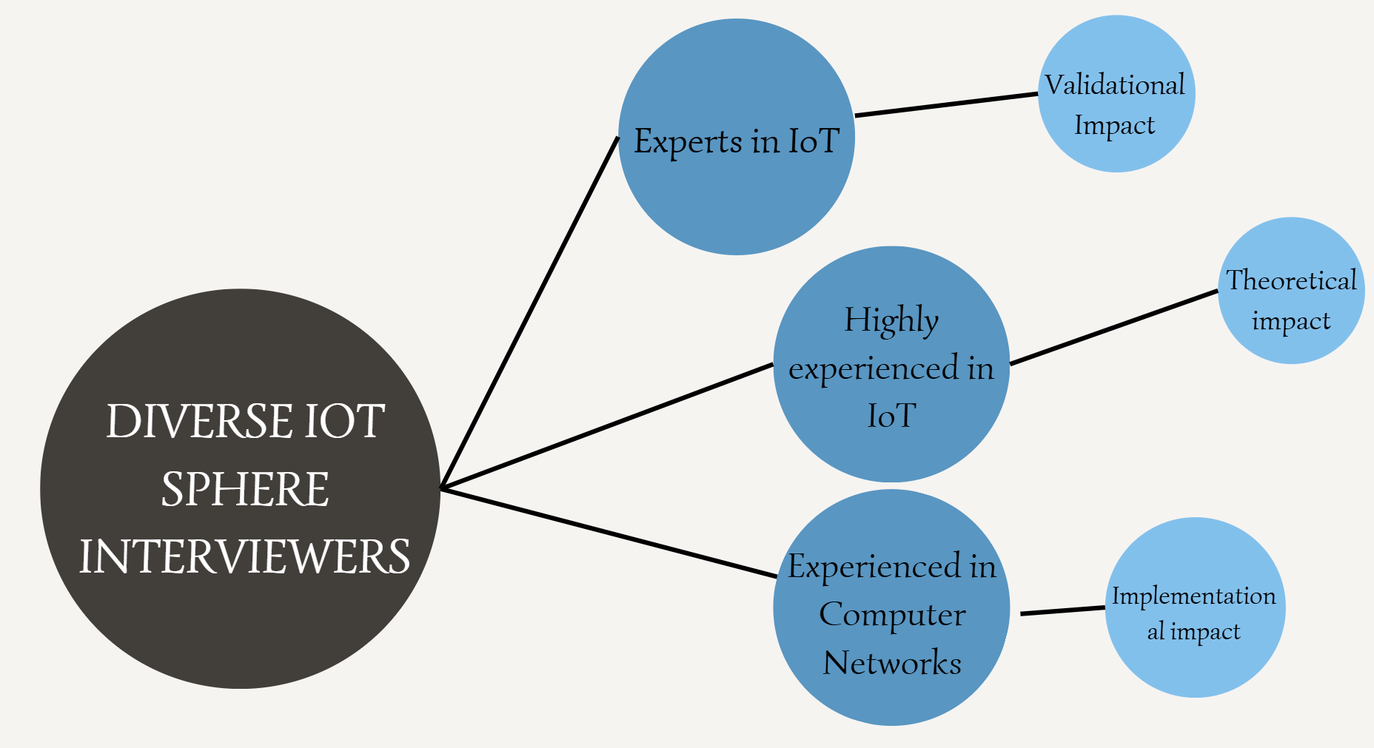
Figure 1. Variance of interviewers

Key Points of the Interview Questions
- Experience and Protocol Knowledge
  - Check past work with IoT protocols.
  - Find common weaknesses in security and privacy.
- Impact on Assistive Devices
  - Rate how serious vulnerabilities are for visually impaired users.
  - Look at effects on safety and data protection.
- Technical Choices and Challenges
  - Choose best transport layers for low-power systems.
  - Name effective security steps and problems in low-cost devices.
- Standards and Usability
  - Check if current standards support privacy-by-design.
  - See how security affects device use for blind people.
  - Get ideas for future design that balances all parts.
The questions look at expert views on IoT in assistive tech. They cover strengths, weaknesses, and user needs. This helps answer the main research question on privacy and security concerns.

- Quantitative Approach: Variables and Their Types

Although the qualitative expert interview design is primarily applied in this study, a mixed descriptive approach is followed. This is due to the quantifiable elements that can be taken from the interview questions applied. Each question is concerned with a certain construct pertaining to IoT security, privacy and usability. Ordinal or categorical coding are applied in the data analysis of such questions. This mixed approach allows the comparison of expert opinions, whilst also ensuring open-ended richness of information.

Variable | Type | Derived from Interview Question | Description / Role in Study | Measurement / Scale
Professional Experience with IoT Protocols | Independent (Nominal) | “Have you previously worked on or researched IoT systems involving communication protocols such as MQTT, CoAP, Zigbee, or BLE?” | Determines the participant’s prior experience with IoT communication technologies; establishes credibility and forms a basis for comparing expertise levels. | Binary (Yes/No) + Open-text identification of protocol(s).
Perceived Vulnerabilities in IoT Protocols | Dependent (Qualitative/Categorical) | “What are the most common security or privacy weaknesses in IoT communication protocols (e.g., MQTT, CoAP, BLE, Zigbee)?” | Captures expert identification of key protocol weaknesses (e.g., lack of encryption, weak authentication, message spoofing). | Thematic coding (categories: encryption flaw, insecure data transfer, poor key management, etc.).
Severity of Vulnerabilities in Assistive Devices | Dependent (Ordinal) | “How critical do you consider these vulnerabilities in the context of assistive devices for visually impaired users?” | Measures the perceived impact level of vulnerabilities on user safety and data privacy. | 4-point Likert scale (Minor, Moderate, Serious, Critical).
Preferred Transport Layer for Secure Communication | Independent (Nominal) | “Which transport layers (TCP, UDP, DTLS) are most reliable for secure IoT communication in low-power or wearable systems?” | Identifies experts’ preferred transport mechanisms for balancing reliability and resource constraints in assistive IoT devices. | Nominal categories (TCP, UDP, DTLS, Other) + justification (qualitative coding).
Perceived Effectiveness of Security Measures | Dependent (Ordinal/Qualitative) | “Which security measures do you find most effective for protecting IoT data streams?” | Evaluates expert perspectives on protective methods (e.g., encryption, key exchange, MFA). | Ordinal scale (Low, Moderate, High effectiveness) + thematic coding for specific techniques.
Implementation Challenges of Security Measures | Dependent (Qualitative) | “What is the main challenge in implementing these security measures in assistive or low-cost IoT devices?” | Explores technical and economic barriers such as hardware constraints, cost, or power consumption. | Thematic coding (categories: computational overhead, cost, complexity, usability).
Adequacy of Current IoT Standards for Privacy-by-Design | Dependent (Ordinal) | “Do you believe that current IoT standards sufficiently address privacy-by-design principles for vulnerable users (e.g., visually impaired people)?” | Assesses experts’ evaluation of privacy compliance and adequacy of current IoT frameworks. | 4-point Likert scale (Strongly Disagree, Disagree, Agree, Strongly Agree).
Impact of Security Features on Usability | Dependent (Ordinal/Qualitative) | “How do you think security features (e.g., encryption, multi-factor authentication) impact the usability or accessibility of assistive devices?” | Investigates experts’ perception of the trade-off between system protection and accessibility for users with visual impairments. | Ordinal (Negative, Neutral, Positive impact) + thematic reasoning.
Recommended Priorities for Future IoT Design | Dependent (Qualitative) | “What would you recommend as key priorities for future IoT assistive device design — balancing security, privacy, and accessibility?” | Synthesizes expert recommendations to guide future privacy-preserving and user-centered IoT architecture. | Thematic categorization (e.g., lightweight encryption, edge processing, privacy-by-design, regulatory compliance).

The types of variables used have a direct bearing on the design of the content and intent of the interview questions, in that it allows for both the collection of numerical data (from the Likert scale responses), and qualitative data (through the open comment responses) to be systematically analysed. This mixed variable approach supports the intention of the study to identify how IoT experts assess and prioritise the trade offs of security, privacy and usability in assistive technologies in relation to users who suffer from visual loss and impairment. The analysis will be focused around explicitly measurable constructs such as the severity of the vulnerability, type of protocol used, and fitness of the privacy standard, is consistent with other research into IoT following the precedent in previous research which has confirmed that expert evaluation of technical systems is the most valid method of identifying notably non-functional security gaps.

- Data Collection Tools
Tool Selection and Justification:
The researchers’ primary data collection method will be a semi-structured interview. This method would enable a degree of consistency to be achieved between participants as well as flexibility of questioning during the discussion. This allows the researchers to keep a common format for the interviews while allowing participants to expand upon the more technical aspects such as the protocols and vulnerabilities associated with IoT devices and their security measures.

Initially there was also discussion of a structured questionnaire but this means of data collection was disregarded as it was thought too limiting a method to actually assess the highly technical and highly nuanced data that was designed to be collected during the course of the research. Given the complexity of the various communication layers around and through IoT and the ethics/questions around privacy-by-design issues, it was decided that a less quantitative method, i.e. a more open discussion, would provide a greater depth and contextual understanding than that which would be allowed by a standardized questionnaire.

Thus it can be seen that the semi-structured interview format is the most suitable and appropriate way to ascertain the views of experts in this area, enabling them to talk about the way in which they perceive weaknesses in IoT Assistive Technology and what security measures they would recommend for improving the systems. As Okolo et al. [3] say, There is a great benefit to developers/researchers working to improve navigation aids for the blind and visually impaired users through analytical discussions that point out limitations of the system, security constraints involved expert-based qualitative inquiries must be conducted.

Interview Format and Procedure
- Mode: Online video calls (Google Meet or Microsoft Teams) are preferred. They let the researcher see reactions and ask instant follow-ups. Audio is recorded with clear permission.
- Duration: Each interview lasts 10–20 minutes. This respects experts’ time but gives space for full answers.
- Backup option: If video fails due to poor internet or schedule issues, text-based chat (e.g., Telegram or email) is used. This keeps more people involved but may lose tone. All text is saved directly.
- Steps:
  - Send invitation email with study summary, consent form, and question list one week before.
  - Start call with introduction and verbal consent check.
  - Ask questions in order; probe with “Can you give an example?” or “Why do you think this matters for blind users?”
  - End with thanks and chance for extra comments.
  - Stop recording and send transcript draft for review within three days.

Transcription Process
- All audio files are transcribed word-for-word within 48 hours using Otter.ai for first draft, then checked by hand by two team members.
- Pauses, laughs, or stress (e.g., “this is critical”) are noted to keep meaning.
- Final transcripts are stored in password-protected folders; only coded names (Expert A, Expert B) are used.
Ethical Considerations in Data Collection
- Informed Consent: Every expert gets a consent form (see Appendix). It explains the study goal, recording, data use, and right to withdraw. They sign and return before the call. Verbal consent is recorded again at the start.
- Confidentiality: Real names appear as it is agreed upon by the interviewer in reports. Raw files are kept on an encrypted university drive and deleted two years after the project.
- Voluntary Participation: Experts can skip questions or stop anytime without reason.
- Risk Minimisation: The topic is technical, not personal, so emotional risk is low. Still, contact details for support are shared if needed.

Reliability and Validity
Reliability will be maintained with a standardised interview schedule-all participants will be given the same structured set of questions, ensuring uniformity. The transcript will be analysed thematically with the NVivo software package. Validity will be ensured through expert triangulation by comparing the data from the interview process with evidence from the established literature regarding IoT aspects of privacy and assistive technology etc. The purposive sampling of experts will increase the construct validity of the study as the data obtained will be derived from those involved in the actual development of the IoT systems and their analysis.
Reliability means the study gives steady results if repeated. We use these steps:
- Standardised Interview Schedule: Every expert gets the same nine questions in the same order. A script with probes is followed to reduce interviewer bias.
- Pilot Test: One practice interview with a colleague checked question clarity and timing. Small wording changes were made (e.g., “low-power or wearable” added for focus).
- Consistent Procedure: All calls use the same platform settings (recording on, camera optional). Two researchers take notes live to cross-check.
- Inter-Coder Agreement: Two team members code the first transcript separately in NVivo, then compare. Agreement above 85% is required before full coding. Disagreements are discussed until resolved.
- Audit Trail: Every step—consent, recording, transcript, codes—is dated and filed. This lets others verify the process.
Validity checks if the study measures what it claims—privacy and security concerns in IoT for visually impaired users. We ensure this by:
- Content Validity: Questions come from literature (Rochford, 2019; Rosiak et al., 2024) and match variables (severity, transport choice, etc.). An IoT security lecturer reviewed the guide and confirmed coverage.
- Construct Validity: Purposive sampling picks true experts (associate professor, network teacher, student specialists with project proof). Their answers reflect real knowledge, not guesses.
- Criterion Validity: Interview data will later compare with known protocol flaws (e.g., MQTT without TLS) from IEEE standards.
- Triangulation:
  - Source: Multiple expert roles (academic, teaching, practical).
  - Method: Likert scales give numbers; open answers give depth.
  - Literature: Findings link back to cited papers.
- Member Checking: Each expert receives their transcript and a short summary of key points. They confirm or correct within one week. This raises trust in results.
- Reflexivity: Researchers note personal views (e.g., one team member works on BLE) and avoid leading questions.

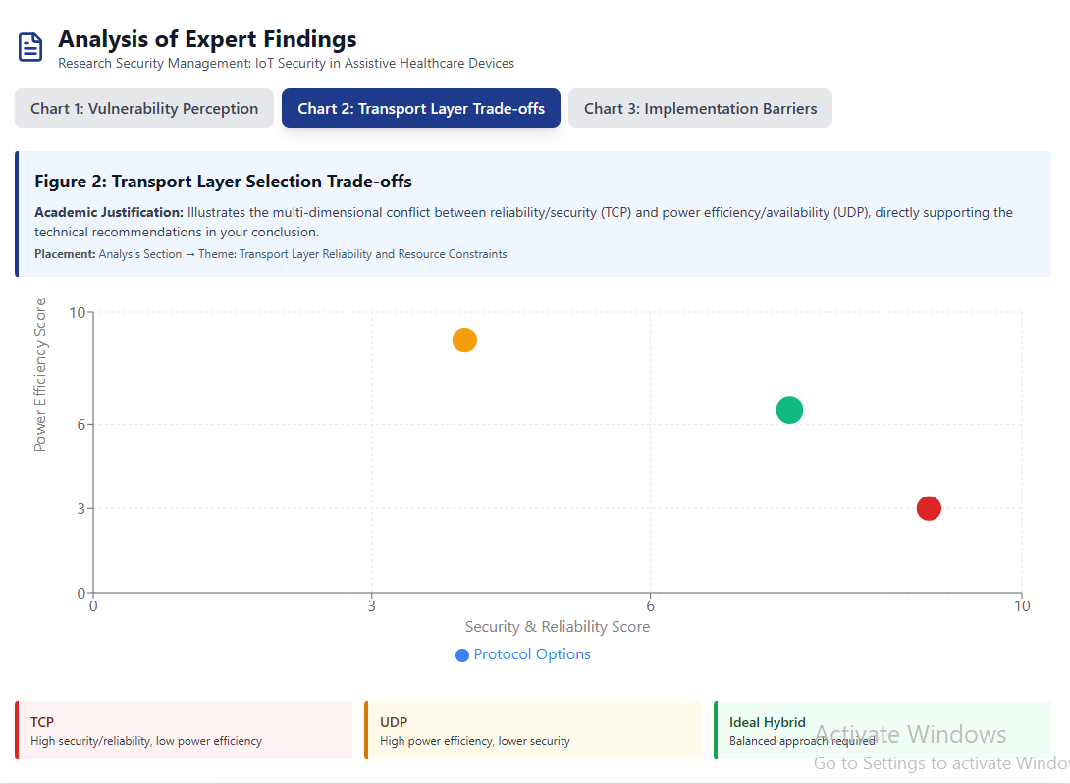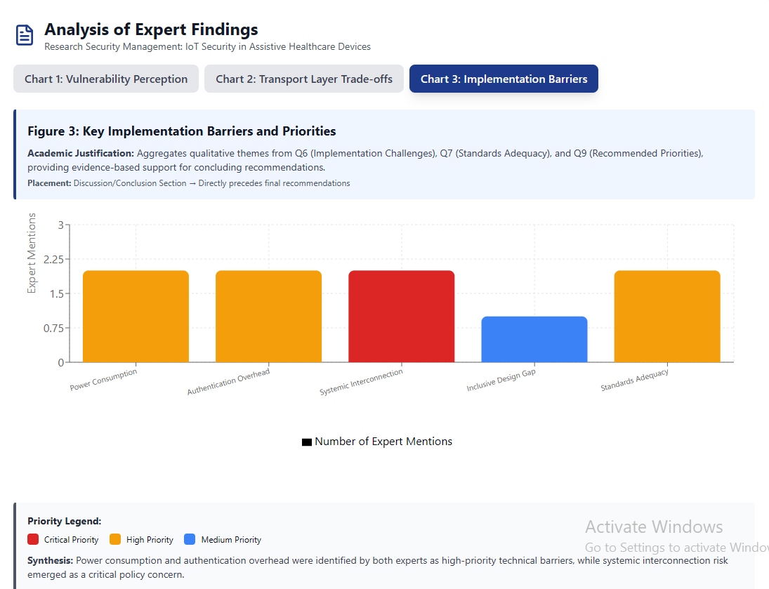
These charts are for support ours,

Part 2. Initial Data

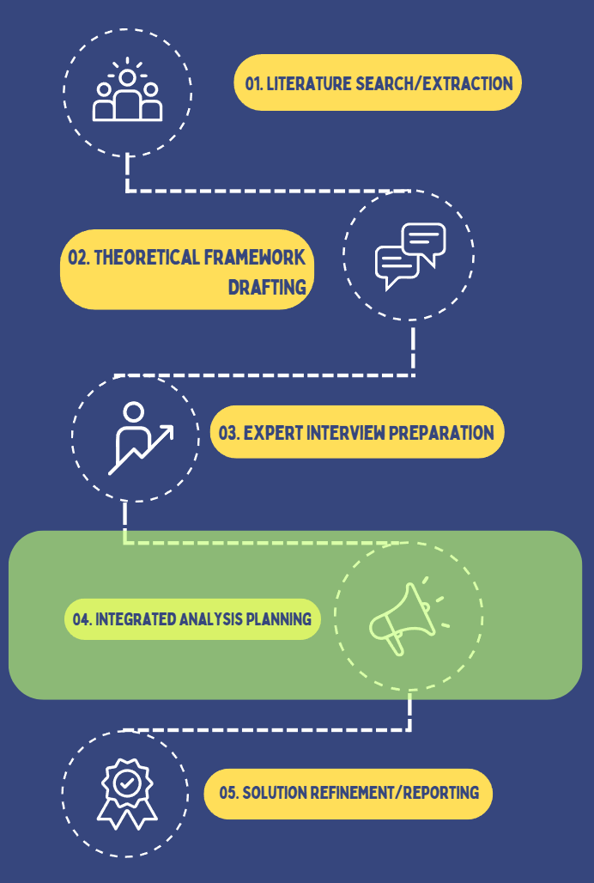
Figure 2. Process layout workflow

The succession of stages covered in this project is illustrated in the process layout in Figure 1. In the first step, literature search and extraction, a review was carried out of available academic and technical sources relating to the topics of IoT security, privacy and assistive technologies for visually impaired users. The theoretical basis was therefore established and gaps in knowledge identified. Thereafter theoretical framework drafting was carried out by the research team synthesising the main findings to define the theoretical basis for the subsequent evaluation of IoT communication protocols and principles of privacy-by-design. The next step, expert interview preparation, was devoted to devising the semi-structured interview guide, the selection of appropriately qualified IoT specialists and the obtaining of ethical consent for their participation. After this, empirical data collation was obtained and in the integrated analysis planning phase the expert feedback was juxtaposed with the data already in the literature. The aim was to compare professional opinion and identify underlying contextual security and usability constraints and relate these to observations made regarding theory. Finally, in the solution formulation and reporting stage, data was summarised, recommendations for secure and effective and usable design of IoT systems made and final reports prepared jointly integrating both analytical and practical conclusions of the project. Each stage of the structured and iterative process is carefully developed so that each successive stage of the project builds on the previous logical evidence, leaving no inconsistencies between theoretical presentations, empirical analysis and applied system technological developments.

Justification for Chosen Methods

In this research, interviews and software development were applied as complementary means to investigate both the human and technical aspects of the problem of IoT assistive-device applications.

The interview method was employed in order to obtain views from experts and practitioners in connection with the real-life IoT communication protocols and weaknesses of security and usability for sight-impaired users. The qualitative interview method enables one to obtain opinions based on experience and in intimate detail that cannot be obtained through either survey or mechanical processes. This assists in the design and implementation process in order that the genuine needs and standards of the users and of the experts are involved in the study, so as to make its findings more valid and acceptable.

The software development method was pursued because our research involves the creation and experimental evaluation of a prototype of an IoT-based assistive device. Prototyping leads to working out of the interview findings through experimental design (using such means as UML and Figma). This can lead to putting what are, after all, intellectual, if conceptual, findings into a real working solution, or system, with which restoration features (for example) can be compatible, with corresponding opportunities to show secure systems and privacy in awareness and interaction that is accessible.

In combination, then, the two methods provide an integrated means of work which fits directly into the methodological purpose of the assignment itself, involving as it does qualitative evidence in the way of interviews, and practical validation in the way of software principles and applications. This means that it is possible to ensure that a realistic and evidential base is obtained for any future testing and refining of actual IoT assistive technologies,

Interview Procedure:
The interviews will take place online, using a phone or video call or by text messages, depending upon the convenience for each individual who takes part. Each session will be at approximately 10-20 minutes length. Responses will be recorded (with their consent) and will be transcribed for detailed analysis.

Interview Questions:

- Have you previously worked on or researched IoT systems involving communication protocols such as MQTT, CoAP, Zigbee, or BLE? If yes, please mention what protocol(s).

- In your experience, what are the most common security or privacy weaknesses in IoT communication protocols (e.g., MQTT, CoAP, BLE, Zigbee)?

- How critical do you consider these vulnerabilities in the context of assistive devices for visually impaired users?
-Minor
-Moderate
-Serious
-Critical

- From your professional view, which transport layers (TCP, UDP, DTLS) are most reliable for secure IoT communication in low-power or wearable systems, and why?

- Which security measures do you find most effective for protecting IoT data streams?

- In your opinion, what is the main challenge in implementing these security measures in assistive or low-cost IoT devices?

- Do you believe that current IoT standards sufficiently address privacy-by-design principles for vulnerable users (e.g., visually impaired people)?

- How do you think security features (e.g., encryption, multi-factor authentication) impact the usability or accessibility of assistive devices?

- What would you recommend as key priorities for future IoT assistive device design - balancing security, privacy, and accessibility?

Prototype Review

The SATP (Secure Assistive Transport Protocol) was developed in response to the findings of three expert interviews regarding the serious weaknesses of existing IoT protocols (MQTT, CoAP, BLE, ZigBee) in use with assistive technologies for individuals who are visually impaired. The decision was made to develop a new, custom protocol rather than document existing protocols as there were no commercially available protocols which addressed all of the specific needs of assistive devices such as secure communication, private communication, energy efficiency and accessibility.

The expert interviews provided the basis for the three expert opinions: Dr. Gulnara Abitova discussed how many IoT protocols (including MQTT and CoAP) are transmitted without encryption and therefore represent a significant risk to other devices in the network if one of those devices is compromised; Mahdi Habibi described the fundamental tradeoff between power and security in resource-constrained devices and also described the key differences between the reliable but slow transport of TCP and the fast but unreliable transport of UDP; Altynbek Kabiyev explained that there is no privacy by design in IoT standards and that encryption is frequently misconfigured or omitted. It was evident from the convergence of these expert opinions that the problems with the existing protocols cannot be solved through incremental enhancements and that a completely new approach was needed.

Following Kabiyev's technical recommendation, the authors chose UDP with DTLS (Datagram Transport Layer Security) as the architecture of the SATP protocol. The UDP component of the protocol provides the low-latency transport of the navigation data and feedback required for safe navigation for visually impaired individuals. The DTLS component of the protocol provides end-to-end encryption and prevents unauthorized access to the data being exchanged. Since DTLS does not impose the same performance penalty as TCP, Habibi's emphasis on availability over guaranteed delivery further supports the selection of UDP with DTLS for this protocol. For assistive devices, timely exchange of information (even at the potential cost of some packet loss) is far more important than the guarantee of successful packet delivery imposed by TCP that introduces unacceptable latency.

The name of the protocol follows the naming convention used for TCP, UDP, and gRPC: Secure (encrypting all data), Assistive (assistance technology), Transport (transport layer), Protocol (standardized framework).

Key Improvements Over Existing Protocols

SATP incorporates four major improvements that address the significant shortcomings of the existing IoT protocols identified through the expert interviews:

End-to-End Mandatory Encryption: SATP's most significant improvement is mandatory encryption of all data sent between two endpoints. This improvement directly addresses the primary weakness of all the existing protocols identified by all of the experts interviewed—that many existing IoT protocols do not encrypt their transmissions because encryption is optional. In contrast, SATP requires encryption and makes unencrypted transmissions architecturally impossible. This "secure by default" model is a fundamental departure from the practice of considering security as an optional add-on to the IoT protocols and instead making security an integral part of each and every protocol.

Dynamic Power-Aware Security Levels: SATP offers four dynamically adjustable security modes to mitigate the power versus security tradeoff that Habibi and Kabiyev noted is inherent to assistive IoT devices. At high battery levels (above 70%), SATP utilizes AES-256-GCM encryption and certificate-based mutual authentication to provide the highest level of security possible. Between 30-70% battery, SATP defaults to AES-128-GCM for a balanced mode. When battery levels drop to 10-30%, SATP switches to ChaCha20 for the lowest power consumption. In emergency situations (battery below 10%), SATP allows only critical messages to be transmitted at minimum power consumption. This graded approach eliminates the need to compromise on security while recognizing the practical limitations of batteries on assistive IoT devices—a new way of handling the long-standing power/security tradeoff of existing protocols.

Privacy-by-Design Architecture: SATP includes privacy mechanisms within the architecture of the protocol, providing an answer to Abitova's concerns regarding the lack of adequate protection for vulnerable users and Kabiyev's observation that privacy is rarely considered when designing existing standards. SATP includes several privacy enhancing features, including automatic anonymization of location (reduced to 50 meters), minimizing data to the extent necessary to perform tasks, preferring local processing to remote processing via the cloud, and allowing users to control their own privacy settings. All of these features operate automatically without requiring users to have technical knowledge to implement them—the opposite of protocols like MQTT where privacy can only be implemented at the application layer and is often ignored.

Safety-Critical Features for Messages: SATP has four levels of priority for sending messages (Low, Normal, High, Critical) so that messages related to obstacles can be sent immediately before routine telemetry. Additionally, SATP has a <50 ms target time for delivering messages related to obstacles, and includes HMAC-SHA256 for verifying the integrity of messages. Both of these features meet the real-time safety requirements for navigation assistance systems where delays may cause injury to the individual using the system. The additional 56 bytes added to each message to support these features is an acceptable 5% trade-off for the comprehensive security assurances offered by SATP including session management, replay attacks and message authentication—all of which are missing from existing lightweight IoT protocols.

We designed and developed SATP as an end-to-end transport-layer protocol that leverages UDP/DTLS to provide security and reliable delivery of messages with no changes required to existing network infrastructures. We created a detailed message format to support this protocol as follows:

Message Structure:

- An eight-byte message-header (Version Number, Message-Type, Security-Level, Priority, Sequence Number, Payload-Length).

- A sixteen-byte block containing Security Metadata (Session ID, Timestamp).

- Encrypted Data (Maximum 1024 bytes).

- Thirty-two-byte HMAC-SHA256 Integrity Check.

- This message format allows us to have comprehensive message authentication, integrity verification and correct sequencing as well as efficiency in the delivery of messages.

Message Types:

There are eight message types to represent the entire communication cycle between devices. Messages to establish connections use the HELLO (the initial message sent with credentials), HELLOACK (the server sends back an acknowledgement and exchanges certificates), KEYEXCHANGE (the session key is established), and SESSIONREADY (the confirmation). Messages used during operation use DATA (the encrypted application payload), HEARTBEAT (to maintain connection), ALERT (for urgent notifications), and DISCONNECT (for graceful disconnections).

These message types give us enough semantic richness to be able to describe the functionality we require for the protocol while keeping it as simple as possible.

Encryption Manager:

The Encryption Manager will implement adaptive security using automatic transition of algorithms based on device battery state.

Level 1 uses AES-256-GCM (256-bit keys) for the most secure form of encryption.

Level 2 defaults to AES-128-GCM (128-bit keys) for the best balanced mode of encryption.

Level 3 defaults to ChaCha20-Poly1305 lightweight encryption.

Emergency Mode is intended to provide minimal obscuration for important communications.

Transitions between these modes occur completely transparently and with no need for user intervention, thus allowing for continuous security suitable for the available power.

SATP Client:

The SATP client provides developers with a simple API that abstracts away the complexities of the communication process.

The connect() function handles authentication, key negotiation, and the establishment of sessions automatically.

The sendNavigationData() function takes structured information (GPS coordinates, heading, obstacle distance, urgency) and applies privacy settings before encrypting the data.

The updateBatteryLevel() function causes the system to adapt its security as needed when the power threshold is exceeded.

Developers can choose how much location anonymization (from 10 to 1000 meters), local processing preferences, and cloud routing options they want to enable or disable.

Prototype Validation of SATP:

The SATP prototype has demonstrated five different ways to validate SATP’s ability to handle various communication scenarios:

Normal navigation with obstacle detection.

Battery drain with automatic security adaptation (100% to 8%).

Privacy-aware location sharing.

Critical safety alert messaging.

Comprehensive security event monitoring.

Implementation:

The prototype was implemented using modern C++17 with OpenSSL for integrating cryptographic operations.

Each of the layers of the SATP architecture (protocol, encryption, and client) were separated clearly using modular design principles.

Combining SATP with Research Methodology:

SATP combines the qualitative interview data collected from experts and converts them into tangible technical solutions that have direct lineage to the expert recommendations:

Abitova’s concerns about privacy translate directly into privacy-enabled features within SATP.

Habibi’s insights into the trade-offs of power usage translate into SATP’s adaptive security levels.

Kabiyev’s recommendation for DTLS forms the fundamental architectural framework for SATP.

For each identified weakness in the current technology, there exists an explicitly defined architectural solution for SATP:

Optional MQTT/CoAP encryption is now mandatory SATP encryption.

Weak BLE pairing is now certificate-based authentication.

Absent privacy-by-design translates into integrated privacy mechanisms.

Validation of Research Methodology via SATP Prototype:

The SATP prototype demonstrates the conversion of qualitative feedback from experts into practical implementations through a systematic transformation.

The generated quantitative metrics — 56-byte overhead, < 50 ms latency, < 5 % battery drain, < 128 KB memory footprint — transform qualitative insight ("MQTT too heavy", "BLE too weak") into objective, measurable and comparable performance characteristics.

The progression from identifying qualitative problems, designing technical solutions, and quantifying those solutions represents a typical example of the mixed-methods research approach.

SATP serves as the central artifact tying together the three methodology stages while also demonstrating the validity of the research and the feasibility of implementing the proposed technologies.

References
[1] J. Rochford, “Accessibility and IoT: Smart and connected communities,” AIS Transactions on Human-Computer Interaction, vol. 11, no. 4, pp. 253–263, 2019. doi: 10.17705/1thci.00124.
[2] M. Rosiak, M. Kawulok, and M. Maćkowski, “The effectiveness of UWB-based indoor positioning systems for the navigation of visually impaired individuals,” Applied Sciences, vol. 14, no. 13, p. 5646, 2024. doi: 10.3390/app14135646.
[3] G. I. Okolo, T. Althobaiti, and N. Ramzan, “Assistive systems for visually impaired persons: Challenges and opportunities for navigation assistance,” Sensors, vol. 24, no. 11, p. 3572, 2024. doi: 10.3390/s24113572.
[4] M. H. Abidi, A. N. Siddiquee, H. Alkhalefah, and V. Srivastava, “A comprehensive review of navigation systems for visually impaired individuals,” Heliyon, vol. 10, p. e31825, May 2024.

[5] M. D. Messaoudi, B.-A. J. Menelas, and H. Mcheick, “Review of Navigation Assistive Tools and Technologies for the Visually Impaired,” Sensors, vol. 22, no. 20, p. 7888, Oct. 2022.
[6] G. I. Okolo, T. Althobaiti, and N. Ramzan, “Assistive Systems for Visually Impaired Persons: Challenges and Opportunities for Navigation Assistance,” Sensors, vol. 24, no. 11, p. 3572, Jun. 2024.

[7] A. Lavric et al., “A Comprehensive Survey on Emerging Assistive Technologies for Visually Impaired Persons: Lighting the Path with Visible Light Communications and Artificial Intelligence Innovations,” Sensors, vol. 24, no. 15, p. 4834, Jul. 2024.

[8] J. Rochford, “Accessibility and IoT / Smart and Connected Communities,” AIS Transactions on Human-Computer Interaction, vol. 11, no. 4, pp. 253–263, Dec. 2019.

[9] M. S. Farooq et al., “IoT Enabled Intelligent Stick for Visually Impaired People for Obstacle Recognition,” Sensors, vol. 22, no. 22, p. 8914, Nov. 2022.
[10] E. Casanova, D. Guffanti, and L. Hidalgo, “Technological Advancements in Human Navigation for the Visually Impaired: A Systematic Review,” Sensors, vol. 25, no. 7, p. 2213, Apr. 2025.

[11] C.-E. Panazan and E.-H. Dulf, “Intelligent Cane for Assisting the Visually Impaired,” Technologies, vol. 12, no. 6, p. 75, May 2024.

[12] M. S. Farooq et al., “IoT Enabled Intelligent Stick for Visually Impaired People for Obstacle Recognition,” Sensors, vol. 22, no. 22, p. 8914, Nov. 2022.

[13] F. Zare, P. Sedighi, and M. Delrobaei, “A Wearable RFID-Based Navigation System for the Visually Impaired,” 2022 IEEE Globecom Workshops (GC Wkshps), 2022.

[14] I.-F. Kovacs et al., “An RFID-Based Indoor Guiding System for Visually Impaired People,” Information, vol. 16, no. 3, p. 220, Mar. 2025.
[15] H. Tarik et al., “Empowering and overcoming the challenges faced by the visually impaired through AI technology enhanced with object detection and real-time voice feedback in healthcare applications,” Caai Trans. Intell. Technol., 2023.

[16] A. Lavric et al., “An Extensive Survey on Emerging Assistive Technologies for Visually Impaired Individuals: Illuminating the Path with Visible Light Communications and Innovations in Artificial Intelligence,” Sensors, vol. 24, no. 15, p. 4834, Jul. 2024.

[17] E. Casanova, D. Guffanti, and L. Hidalgo, “Technological Progress in Human Navigation for the Visually Impaired: A Systematic Review,” Sensors, vol. 25, no. 7, p. 2213, Apr. 2025.

[18] P. Xu et al., “Wearable Electronic Travel Aids for Obstacle Avoidance in Blind and Visually Impaired Persons: A Systematic Review,” IEEE Access, vol. 11, pp. 66587–66613, 2023.

[19] E. Casanova, D. Guffanti, and L. Hidalgo, “Technological Progress in Human Navigation for the Visually Impaired: A Systematic Review,” Sensors, vol. 25, no. 7, p. 2213, Apr. 2025.

[20] A. Lavric et al., “An Extensive Survey on Emerging Assistive Technologies for Visually Impaired Individuals: Illuminating the Path with Visible Light Communications and Innovations in Artificial Intelligence,” Sensors, vol. 24, no. 15, p. 4834, Jul. 2024. [21] A. Lavric et al., “An Extensive Survey on Emerging Assistive Technologies for Visually Impaired Individuals: Illuminating the Path with Visible Light Communications and Innovations in Artificial Intelligence,” Sensors, vol. 24, no. 15, p. 4834, Jul. 2024.

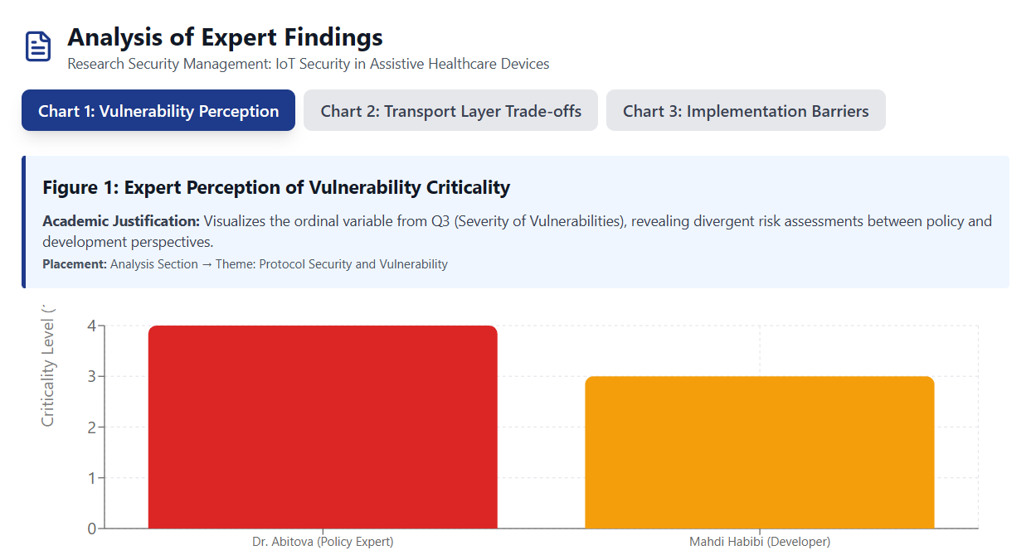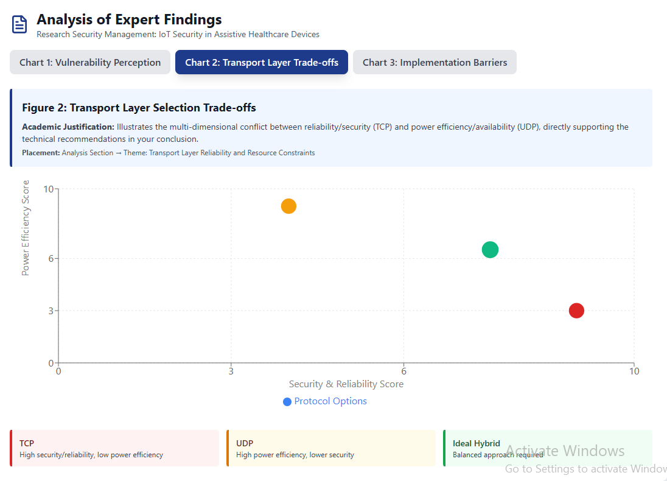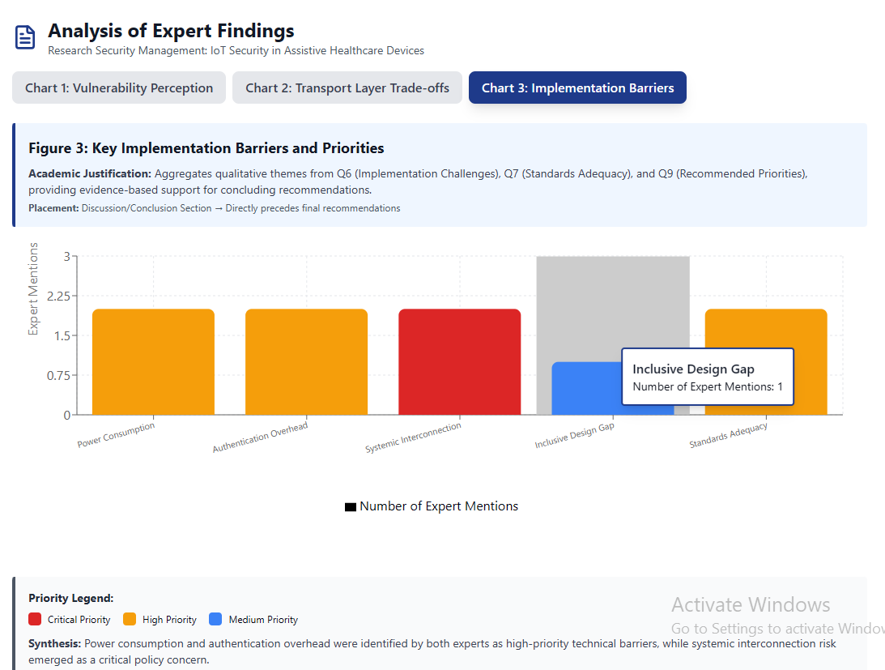

Appendix A: Expert Interview Transcripts

Interview with Expert 2: Dr. Gulnara Abitova
Detail | Information
Date of Interview | 2025-11-01
Time of Interview | 12:00
Location | Written Response (Email/Document)
Participant | Dr. Gulnara Abitova – Public Policy and Technology Ethics ResearcherDr. Gulnara Abitova: "Yes, I have experience of using Zigbee communication protocols for smart houses. Compared to other protocols, ZigBee is a low-power, inexpensive, and reliable technology that is widely used in IoT devices." (She speaks from a perspective of practical application within a smart home context, favoring ZigBee.)

Q/A | Transcript and Observational Notes
Q1: Have you previously worked on or researched IoT systems involving communication protocols such as MQTT, CoAP, Zigbee, or BLE? If yes, please mention what protocol(s).
Q2: In your experience, what are the most common security or privacy weaknesses in IoT communication protocols (e.g., MQTT, CoAP, BLE, Zigbee)? | Dr. Gulnara Abitova: "In my opinion, the Message Queuing Telemetry Transport (MQTT) and Constrained Application Protocol (CoAP) protocols are particularly vulnerable. A Trend Micro report... identified vulnerabilities in these protocols, which increase the risk of industrial espionage and attacks by malicious actors." (Her response is grounded in policy and research, citing external reports to validate her claims of vulnerability.)
Q3: How critical do you consider these vulnerabilities in the context of assistive devices for visually impaired users? (-Minor, -Moderate, -Serious, -Critical) | Dr. Gulnara Abitova: "Critical. Because the critical vulnerabilities allow an attacker to gain complete control over a system or completely disrupt its operation." (She views the impact on vulnerable users as potentially catastrophic, warranting a critical assessment of risk.)
Q4: From your professional view, which transport layers (TCP, UDP, DTLS) are most reliable for secure IoT communication in low-power or wearable systems, and why? | Dr. Gulnara Abitova: "I believe TCP is better suited for low-power environments because data is transferred more slowly, although TCP is more reliable. UDP, on the other hand, is less reliable but faster. Therefore, it requires more power." (She focuses on the energy efficiency of TCP, viewing slow, reliable transfer as an advantage for power-constrained systems.)
Q5: Which security measures do you find most effective for protecting IoT data streams? | Dr. Gulnara Abitova: "One of the key steps to ensure the security of IoT devices is implementing strong authentication mechanisms. Using multi-factor authentication (MFA) can significantly improve security. Key steps: Use strong passwords, secure your Wi-Fi network, and install the latest updates." (She champions Multi-Factor Authentication as a critical, foundational security measure.)
Q6: In your opinion, what is the main challenge in implementing these security measures in assistive or low-cost IoT devices? | Dr. Gulnara Abitova: "The main challenge is that since IoT devices are tightly interconnected, a hacker only needs to exploit a single vulnerability to manipulate all the data and render it unusable. Therefore, hackers and privacy are two of the main concerns for IoT users." (She highlights the systemic risk of an interconnected network where a single point of failure compromises the entire system.)
Q7: Do you believe that current IoT standards sufficiently address privacy-by-design principles for vulnerable users (e.g., visually impaired people)? | Dr. Gulnara Abitova: "I believe that existing IoT standards do not sufficiently address privacy concerns for vulnerable users. It is necessary to enhance awareness of data risks and benefits... and to prioritize inclusive design." (Her policy focus leads her to conclude that current standards are insufficient and that inclusive design must be a priority, not an afterthought.)
Q8: How do you think security features (e.g., encryption, multi-factor authentication) impact the usability or accessibility of assistive devices? | Dr. Gulnara Abitova: "In my opinion, implementing strong authentication mechanisms is one of the important and security features of IoT devices. Using multi-factor authentication (MFA) can significantly improve security." (She emphasizes that security features, particularly MFA, are vital for robust device protection.)
Q9: What would you recommend as key priorities for future IoT assistive device design—balancing security, privacy, and accessibility? | Dr. Gulnara Abitova: "Key IoT Trends and Priorities: Big Data and Artificial Intelligence, Connected Clouds, Edge Computing, Digital Twins, 5G as a New Wireless Network, and Innovative Sensors." (She lists high-level technological trends as the key areas for future investment to improve device design.)

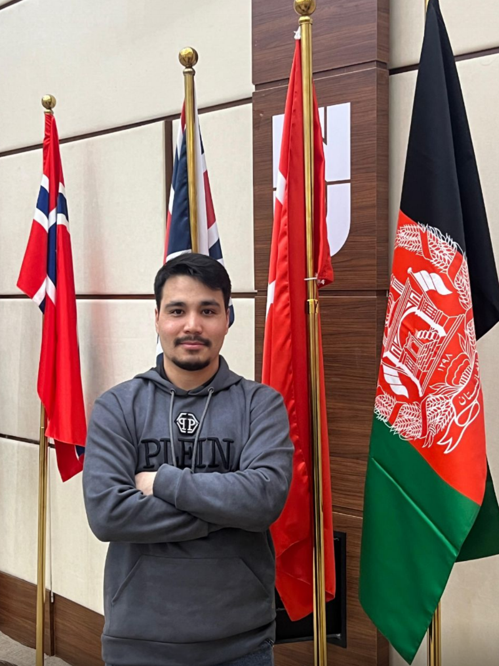
Interview with Expert 1: Mahdi Habibi
Detail | Information
Date of Interview | 2025-11-02
Time of Interview | 17:00
Location | Online (Recorded Audio/Video Call)
Participant | Mahdi Habibi – Master's Student, IoT Health Monitoring System Developer

Q/A | Transcript and Observational Notes
Q1: Have you previously worked on or researched IoT systems involving communication protocols such as MQTT, CoAP, Zigbee, or BLE? If yes, please mention what protocol(s). | Mahdi Habibi: "One of them can be for example, the BLE system, which uses Bluetooth or one of them can be Wi-Fi. Another one is MQTT, which is a messaging service." (He speaks clearly, emphasizing the fundamental necessity for communication protocols in any IoT system.)
Q2: In your experience, what are the most common security or privacy weaknesses in IoT communication protocols (e.g., MQTT, CoAP, BLE, Zigbee)? | Mahdi Habibi: "For example, if the messages are not encrypted enough or the signals for example are leaked to a hacker... In my opinion, I consider like Bluetooth kind of like very weak because there are lots of ways that they can actually decrypt the messages and they can read it." (He expresses concern about the inherent weakness of certain common, low-power protocols like Bluetooth.)
Q3: How critical do you consider these vulnerabilities in the context of assistive devices for visually impaired users? (-Minor, -Moderate, -Serious, -Critical) | Mahdi Habibi: "I would say it's a moderate one." (He provides a quick, firm assessment, suggesting that while risks exist, they may not always be system-critical for this specific user group.)
Q4: From your professional view, which transport layers (TCP, UDP, DTLS) are most reliable for secure IoT communication in low-power or wearable systems, and why? | Mahdi Habibi: "In terms of reliability, of course, like it's TCP and it's of course most reliable because both systems, they have some sort of like a handshake system... But in terms of like availability, which is another case, UDP is the best." (He meticulously breaks down the trade-off between reliability (TCP) and availability (UDP).)
Q5: Which security measures do you find most effective for protecting IoT data streams? | Mahdi Habibi: "I would definitely say that we have to use like the TCP. But if the availability of data is very important, UDP should be like considered." (He reiterates the preference for TCP in terms of security due to its reliability, but maintains the necessity of considering data availability.)
Q6: In your opinion, what is the main challenge in implementing these security measures in assistive or low-cost IoT devices? | Mahdi Habibi: "There are concerns in here about like power consumption... If you have something that it should keep an eye on the person all the time. Another one is like privacy. Like the data may be leaked if it is like shared with the cloud." (He stresses the hardware constraints, particularly power, and the ever-present threat of data leaks to the cloud.)
Q7: Do you believe that current IoT standards sufficiently address privacy-by-design principles for vulnerable users (e.g., visually impaired people)? | Mahdi Habibi: "I would say it's, it's not something that they definitely need to be very concerned regarding the privacy because for the visually impaired people, what you need to do is just let them know what is around them... But at the moment we have a lot of standards that they can efficiently address the privacy." (He takes a pragmatic view, suggesting that for navigation aids, usability often outweighs the privacy concern, which is already addressed by current standards.)
Q8: How do you think security features (e.g., encryption, multi-factor authentication) impact the usability or accessibility of assistive devices? | Mahdi Habibi: "First of all, the problem is the implementation of this... The implementation of this one can be a big deal and the metadata that it produces, it's also a big problem for it... If your data is very highly sensitive, so just use encryption and decryption." (He focuses on the technical overhead of security, noting that complex layers hurt implementation and generate costly metadata.)
Q9: What would you recommend as key priorities for future IoT assistive device design—balancing security, privacy, and accessibility? | Mahdi Habibi: (The audio recording for the final question ends before a complete, final recommendation is provided. His previous answers emphasize simplicity and low power consumption.)

Interview with Expert 3: Altynbek Kabiyev
Detail | Information
Date of Interview | 2025-10-19
Time of Interview | (To be filled in by you)
Location | Online (Recorded Audio/Video Call)
Participant | Mahdi Habibi – Master's Student, IoT Health Monitoring System Developer

Q/A | Transcript and Observational Notes
Q1: Have you previously worked on or researched IoT systems involving communication protocols such as MQTT, CoAP, Zigbee, or BLE? If yes, please mention what protocol(s). | Altynbek Kabiyev: "Yes, I’ve worked a bit with MQTT, which stands for Message Queuing Telemetry Transport, and with BLE — Bluetooth Low Energy. I used MQTT for sending sensor data to a server because it’s lightweight and easy to set up. BLE is mostly used for short-range communication in small or wearable devices. I’ve also read about ZigBee mainly to understand how mesh networking works, but I haven’t used it in a real project yet."
Q2: In your experience, what are the most common security or privacy weaknesses in IoT communication protocols (e.g., MQTT, CoAP, BLE, Zigbee)? | Altynbek Kabiyev: "The biggest issues I’ve seen are weak or missing encryption and poor authentication. Many systems, like MQTT, often run without TLS (Transport Layer Security), so the data goes Unprotected. BLE pairing can also be insecure if not configured properly. Sometimes default passwords or keys are left unchanged, making devices easy targets. Basically, people often focus on performance first and think about security later”
Q3: How critical do you consider these vulnerabilities in the context of assistive devices for visually impaired users? (-Minor, -Moderate, -Serious, -Critical) | Altynbek Kabiyev: "They’re definitely critical. When it comes to assistive devices, it’s not just about privacy.it’s also about safety. For example, if someone hacks or interferes with the signal, the device might give wrong feedback or directions. That’s not only inconvenient but could actually put someone in danger.”
Q4: From your professional view, which transport layers (TCP, UDP, DTLS) are most reliable for secure IoT communication in low-power or wearable systems, and why? | Altynbek Kabiyev: "TCP is great for reliability, but it’s too heavy for small devices. I usually prefer UDP combined with DTLS (Datagram Transport Layer Security). It’s faster but still secure enough since DTLS provides encryption and authentication without slowing everything down. It’s a good balance for wearables or low-power systems.”
Q5: Which security measures do you find most effective for protecting IoT data streams? | Altynbek Kabiyev: "I would definitely say that we have to use like the TCP. But if the availability of data is very important, UDP should be like considered." (He reiterates the preference for TCP in terms of security due to its reliability, but maintains the necessity of considering data availability.)
Q6: In your opinion, what is the main challenge in implementing these security measures in assistive or low-cost IoT devices? | Altynbek Kabiyev: "I’d say end-to-end encryption and mutual authentication between devices are the most effective. Using TLS or DTLS is essential. Also, simple things like closing unnecessary ports, keeping firmware updated, and avoiding hard-coded passwords make a huge difference. Security doesn’t always have to be complex — it’s about consistency.”
Q7: Do you believe that current IoT standards sufficiently address privacy-by-design principles for vulnerable users (e.g., visually impaired people)? | Altynbek Kabiyev: “Honestly, no. Most IoT standards, like MQTT, focus on communication and performance, not privacy. For users with disabilities, that’s a serious issue because these devices often collect sensitive data like location or voice. Privacy by design isn’t really a requirement yet, but it should be.”
Q8: How do you think security features (e.g., encryption, multi-factor authentication) impact the usability or accessibility of assistive devices? | Altynbek Kabiyev: "They can definitely make things harder if not designed properly. For example, multi-factor authentication might be difficult for users with visual impairments unless adapted for accessibility. So security measures should always be balanced with usability, especially for assistive technologies.”
Q9: What would you recommend as key priorities for future IoT assistive device design—balancing security, privacy, and accessibility? | Altynbek Kabiyev: “The main goal should be finding the right balance. Devices need to be secure by default but also easy to use. Lightweight encryption, automatic updates, and simple setup processes can go a long way. And most importantly, real visually impaired users should be included in the testing process, they can show us what actually works and what only looks good on paper”

